Broadleaf

Getting Started

Overview
Thanks for exploring Broadleaf Commerce! With this tutorial, you'll have your eCommerce site launched in no time. We'll get your environment up and running, show you where things live, and walk you through a few examples of some of the cool things you can do with Broadleaf.

Prerequisites
- First, download the Java 8 Development Kit (JDK)
Debugging Startup Issues
- You will also need the latest version of Maven (at least version 3.1, version 3.2 is recommended), which you can get on the official Apache Maven site

IDE Setup
Note: The first part of this Getting Started guide will cover using our prepackaged Eclipse workspace. If you are an advanced user and would prefer to set up the project yourself, please feel free to follow the Eclipse Setup or Intellij Setup guide.
Once you have the Java SDK installed, we're ready to get your IDE up and running. Let's start by downloading Eclipse.
Download Link: Eclipse IDE for Java EE Developers
Once Eclipse is done downloading, extract the archive and start it up. You'll be prompted for a workspace:
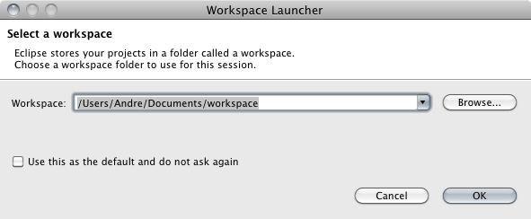
Go ahead and accept the initial value.
Note: Don't save this as the default workspace -- we're going to be setting up a new workspace shortly.
Click on Help --> Eclipse Marketplace and search for Maven Integration. Make sure you pick the plugin provided by Eclipse.org as highlighted below:
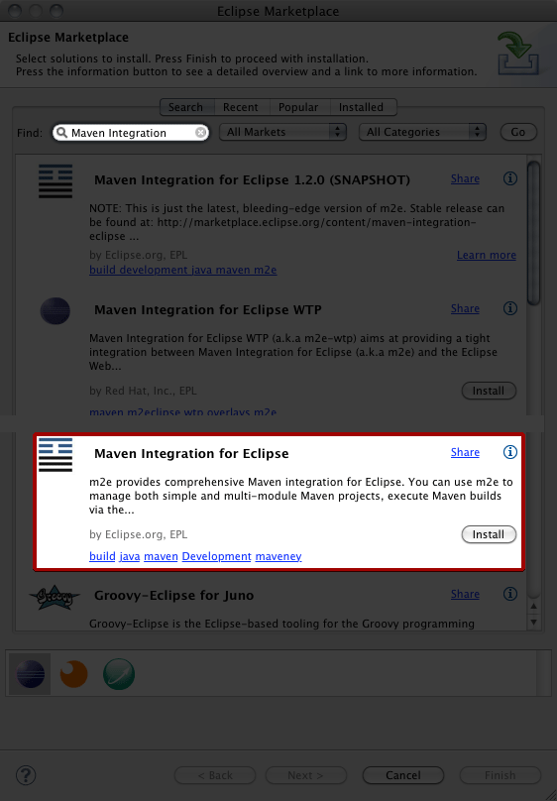
Click Install followed by Next. After that, Accept the License Terms and Finish.
Once the plugin is done installing, you will be prompted to restart Eclipse. Go ahead and do so.
You'll once again be asked for a workspace. This time, we're going to pick a different one. To make getting started with Broadleaf as easy as possible, we've already set up a workspace with some reasonable defaults and tweaks to help you out. Let's download it!
Broadleaf 4.0 workspace Download Link: Broadleaf Eclipse Workspace
Note: If you're not prompted for a workspace, simply go to File --> Switch Workspace and select the path
Extract this archive to the location you want your workspace to live in, and point Eclipse to the appropriate path. This time, your workspace should look like this:
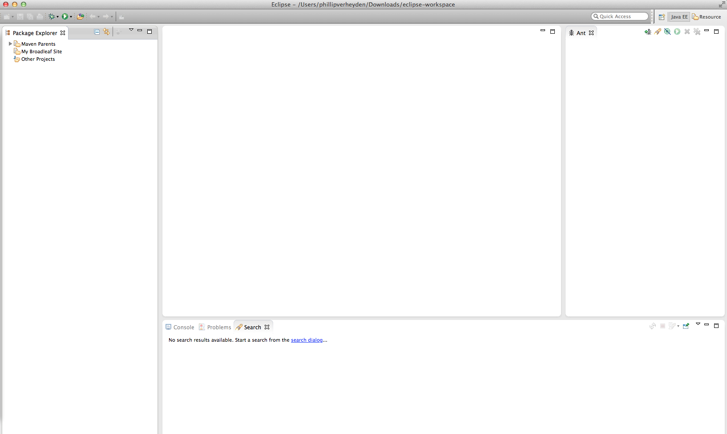
Now we need to import the root ant targets. In the ant view pane, click the 'Add Build Files' button (the button farthest to the left). Select the build.xml from the root DemoSite project and then hit 'Ok':
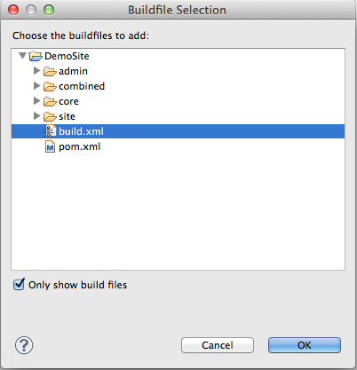
We now need to import the subprojects, core, site, and admin. We do this by going to File --> Import, and picking Existing Maven Projects, like this:
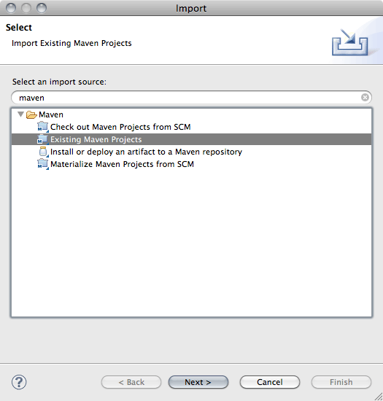
Click Browse and pick the DemoSite folder as the project root, and click Open
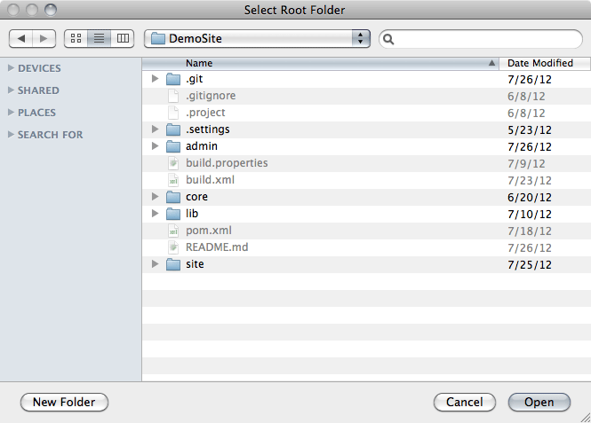
On this screen, make sure you check the Add project(s) to working set box and pick the My Broadleaf Site working set. Also make sure that all four project boxes are checked
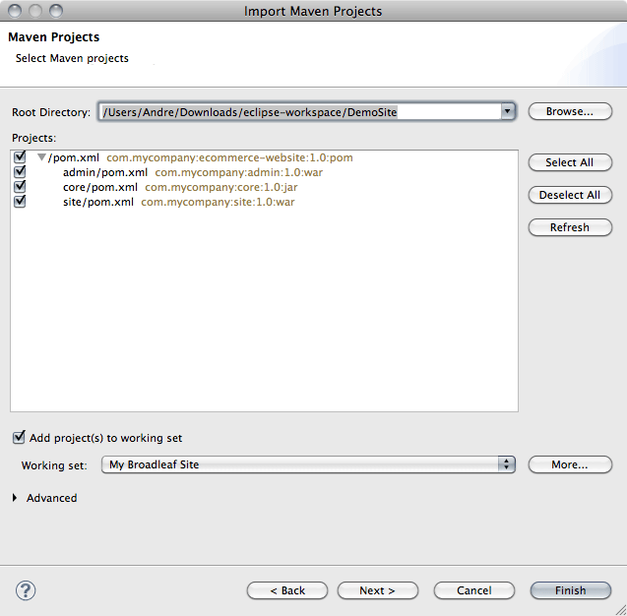
This process may take a while. You can see the progress in the bottom right of Eclipse or open the Maven Console for more detail progress reports.
Once the import is complete, you'll have to add two buildfiles, one for site and one for admin. Click on the Add Buildfiles button on the Ant pane
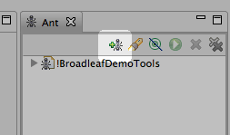
and select the two buildfiles to add:
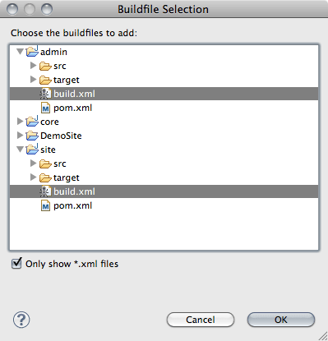
The last thing to do is configure the path of your local maven installation. This is done in DemoSite/build.properties on the maven.home line.
NOTE Windows users must use forward slashes (/) for paths, not backslashes ()
That's it! Now you have your IDE completely setup to work with Broadleaf Commerce, and your workspace should look like this
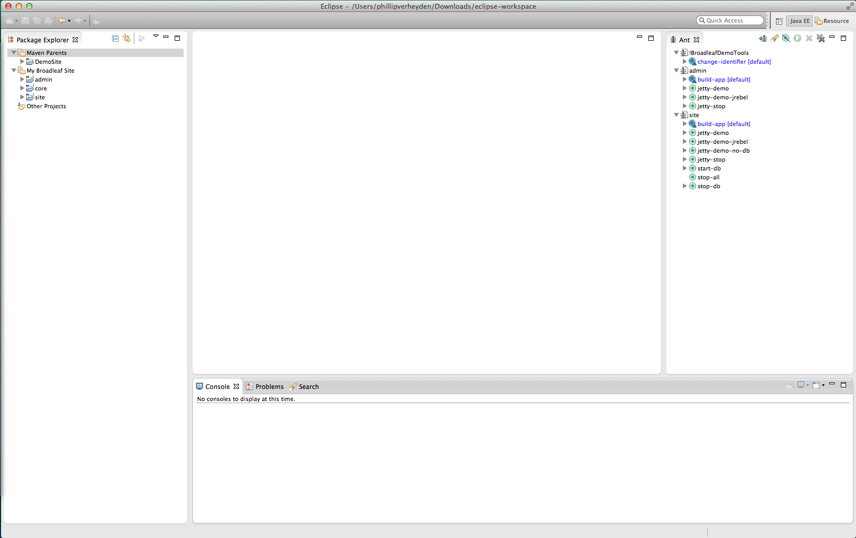

Running Site
Now that we have our workspace properly configured, we're able to get our demo site up and running. First, we will have to let Maven fetch the necessary dependencies and install our own project locally. To do that, Right click on DemoSite --> Run As --> Maven Install.
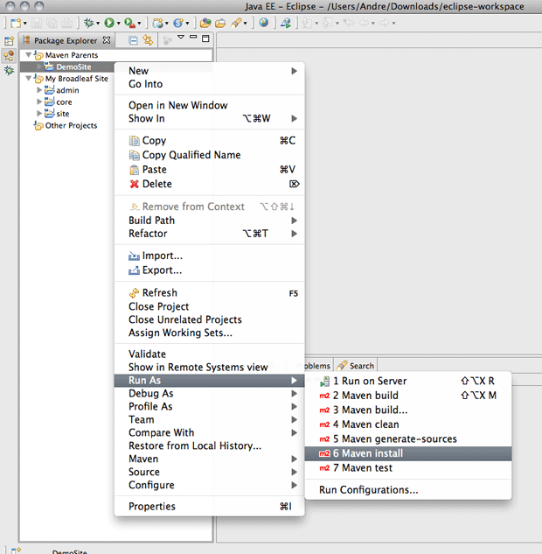
Note: Running a Maven install is only necessary initially. To shorten your development iteration times, you utilize JRebel, which will allow you to modify files without having to restart the server. We've detailed out how to setup JRebel for you.
This process will take a few minutes to execute, and will end on the following success message:
[INFO] Reactor Summary:
[INFO]
[INFO] ecommerce ......................................... SUCCESS [0.440s]
[INFO] core .............................................. SUCCESS [2.505s]
[INFO] admin ............................................. SUCCESS [3:37.628s]
[INFO] site .............................................. SUCCESS [24.109s]
[INFO] ------------------------------------------------------------------------
[INFO] BUILD SUCCESS
[INFO] ------------------------------------------------------------------------
[INFO] Total time: 4:05.052s
[INFO] Finished at: Mon Jul 30 10:01:19 CDT 2012
[INFO] Final Memory: 13M/81M
At this point, we're ready to start up! Let's run the tomcat Ant task for the site.
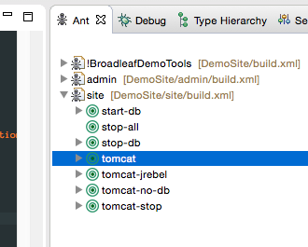
You'll see some logging messages in the Console scroll by, and eventually stop on
[artifact:mvn] Apr 19, 2015 11:16:24 PM org.apache.coyote.AbstractProtocol start
[artifact:mvn] INFO: Starting ProtocolHandler ["http-bio-8080"]
[artifact:mvn] Apr 19, 2015 11:16:24 PM org.apache.coyote.AbstractProtocol start
[artifact:mvn] INFO: Starting ProtocolHandler ["http-bio-8443"]
That's it! The server's up! Let's check it out: http://localhost:8080/
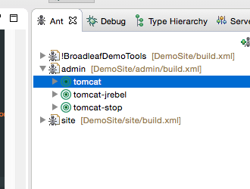

Running Admin
Once the site has been started up, we can start up the admin as well
Note: The site startup will conveniently populate some database tables, including the admin users tables. Therefore, the site must be running before starting up the admin.
This time, we'll hit the tomcat Ant task for the admin.
This console will end up at
[artifact:mvn] Apr 19, 2015 11:16:24 PM org.apache.coyote.AbstractProtocol start
[artifact:mvn] INFO: Starting ProtocolHandler ["http-bio-8081"]
[artifact:mvn] Apr 19, 2015 11:16:24 PM org.apache.coyote.AbstractProtocol start
[artifact:mvn] INFO: Starting ProtocolHandler ["http-bio-8444"]
And now we can hit the admin! https://localhost:8081/admin. At the login prompt, enter the default username/password of admin/admin and you should see the below screen:
Note: The admin to serves all of its pages over https by default. This means that you will encounter a security exception in your browser because the certificates do not match up. You should be able to safely ignore this warning (when running locally).
Any issues? Please come post in the Broadleaf forums - We would love to help you oLearn how to use your own MySQL database server.

© 2014 Broadleaf Commerce
All Rights Reserved

